Comments on the Original Outline Planning Permission that was passed by the Council in 2019.

- The warehouses have been moved closer to residential properties.
At Outline Planning two options were under consideration as shown:

Option 1:
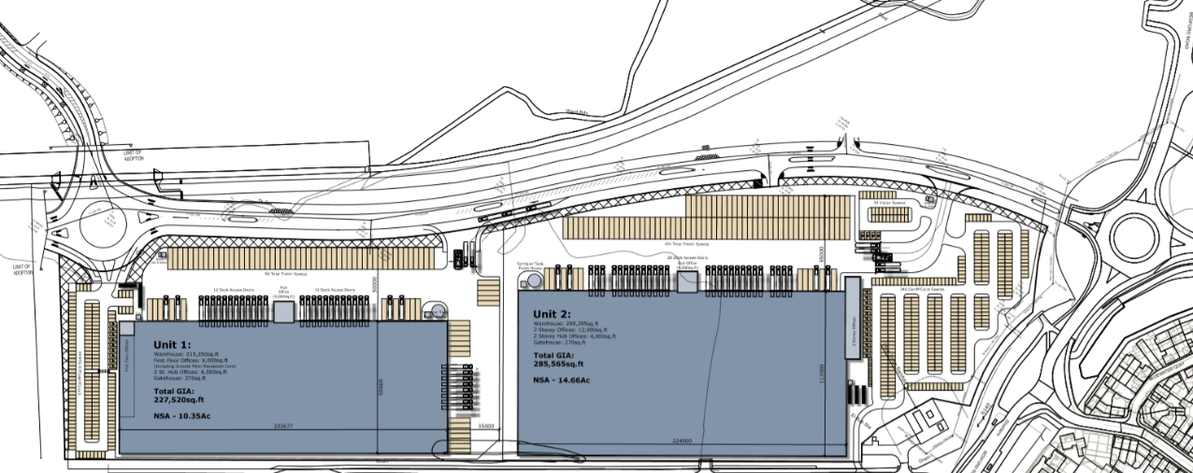

Option 2:
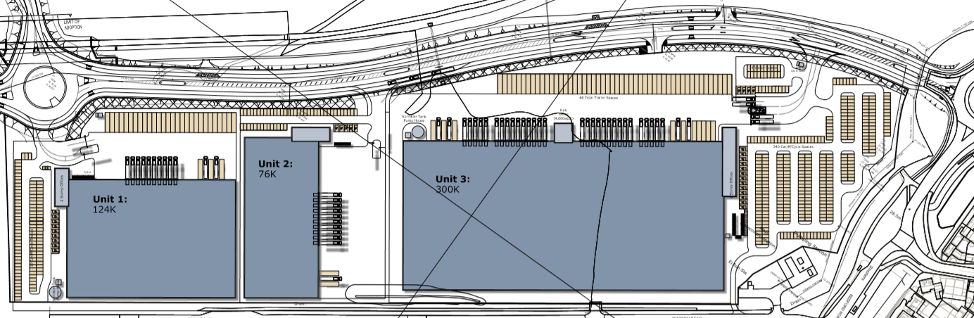

Both options showed the proposed warehouses to be much further away from residential properties than the current proposal shown below:
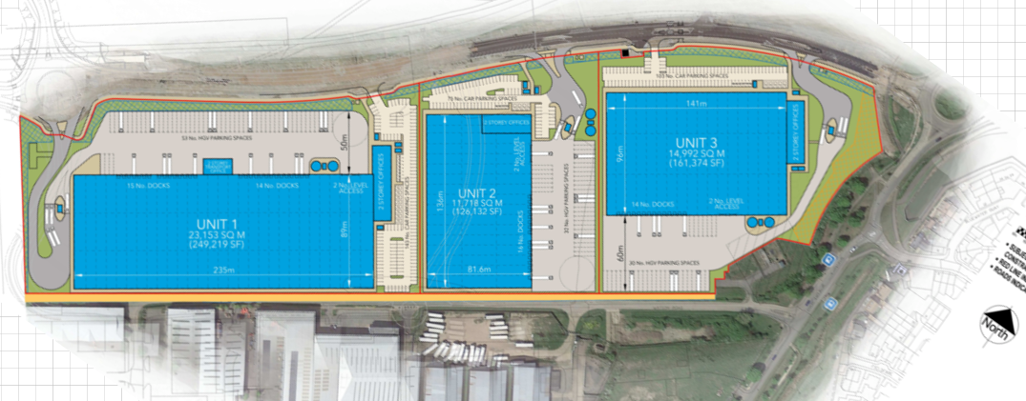

- Inadequate Visual Impact Assessment

The Visual Impact Assessment was the only document that set out the height of the warehouses – It was not indicated on any drawings. This lengthy document had one sentence that stated that ‘the proposed employment units will have a maximum height, to ridge, of 18m measured from the finished floor level.’

Visual impact considerations in outline planning stage came to the following conclusions:
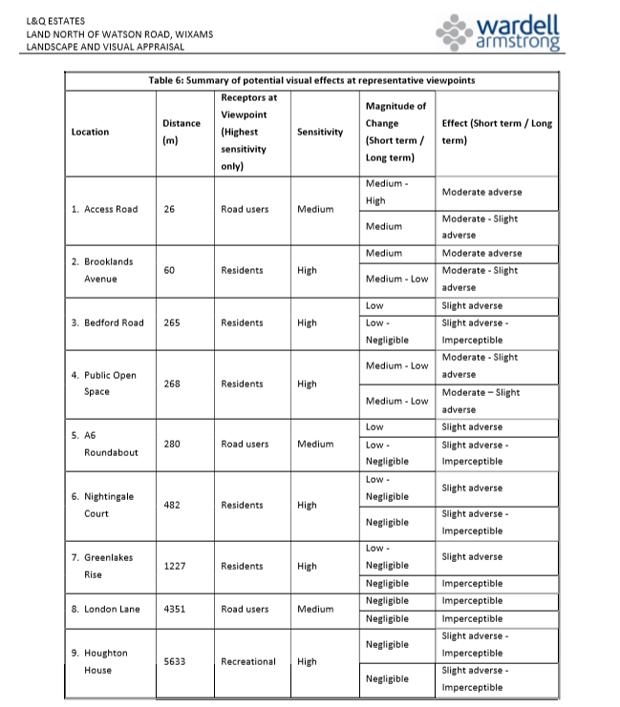
It would appear that there was no consideration of impact on Wixams Retirement Village or Fieldfare View

- No consideration of cumulative impact of all developments.
The documents dated May 2019 state – ‘This appraisal has not considered potential cumulative effects of the proposed development in any detail.’

